Case History: Mapping Gold Alteration using EmPower™ Helicopter Time Domain Electromagnetics
In this example in volcanics, there is an active gold mine in the area making the region prospective for associated offshoots of mineralization.
The object of the survey was to map the extent of the volcanics, but more importantly, show their relationship to any detected alteration imaged using Terraquest’s EmPower™ Helicopter Time Domain Electromagnetics system.
Putting an EmPower™ EM Survey into Action for Gold Alteration near Volcanics
In working on the project, survey design personnel were led by several factors including the effectiveness of helicopter time domain electromagnetics for mapping volcanics based on their contained sulphides as well as alteration containing re-mobilized sulphides.
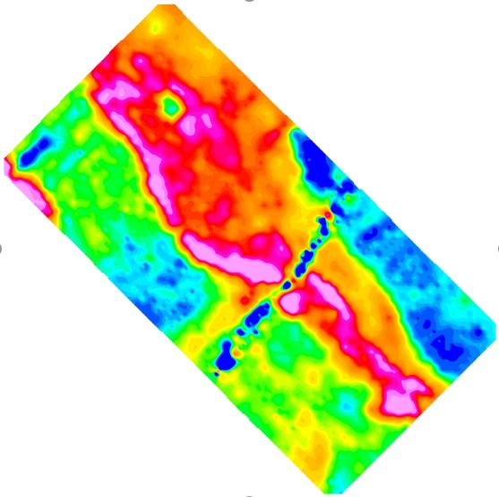
Figure 1: Volcanic unit is highest amplitude (red) linear trend running from southeast to northwest. Alteration zone appears in orange proximal to the volcanics.
The specific results are that:
- The volcanic unit contains an active gold mine to the northwest that is moderately conductive.
- The volcanic unit also contains conductive alteration zones (hydrothermal fractures that have altered the volcanics) that are thought to hold the gold mineralization.
- The project goal was achieved in mapping the outline of the volcanic unit and in identifying the alteration trends within.
- The area has several powerlines, highways, and houses – powerline is linear cross-cutting feature in blue.
For More Information
Terraquest would be pleased to discuss Empower™ helicopter time domain electromagnetic surveys and interpretation approaches with you, including inversions of existing or planned data. For more information, click here <LINK to EASY-QUOTE form>.

